Document History

Version Number | Date | Approved By | Purpose
0.0.1

Inland ECDIS concept, limitations, and challenges

While a type approved maritime ECDIS is allowed to display S-401 IENCs when the vessel is outside of SOLAS regulated areas, it is not required by S-98 that every maritime ECDIS needs to be able to display IENCs correctly. An Inland ECDIS or Inland ECS may also be approved as a maritime ECDIS in accordance with S-98 and the IMO standards, but it is not required. An Inland ECDIS or Inland ECS can also be used as an ECS in SOLAS areas if it is able to display S-101 ENCs, but is not type approved as maritime ECDIS

Depth Related Functionality
S-100 Inland ECDIS and Inland ECS allows water levels to be automatically adjusted using an interoperable combination of S-401, S-102 and S-104 data, both for monitoring and planning purposes. This is described fully in appendix D of this document.

Data Layers

Data products and information layers

Basic product specifications and layers
The Inland ECDIS must be able to process and display at least the following data products:
- S-401 IENC data as the base layer, alongside S-57 based IENC data (editions 2.4 to 2.6) during the transition period;
- S-102 Bathymetric Surface, only for Enhanced Safety Contour and Water Level Adjustment (Appendix D);
- S-104 Water Level information for Surface Navigation, only for Water Level Adjustment (Appendix D);

The IENC layer (S-401 and S-57) must be permanently on. The boatmaster must be able to switch the graphical display and processing of other S-100 products on and off. Graphical display of S-401 is defined in Appendix E. S-102 and S-104 processing is contained in Appendix D.

Special Inland ECDIS chart symbols to identify unsafe depths
The Inland ECDIS highlights four concepts that are important for safe navigation. These are the safety contour, depth shades, the safety depth and isolated dangers. Depth shades, safety depth and isolated dangers are implemented in the portrayal catalogue.

Safety Contour
The own-ship safety contour is double-coded by a thick line and a prominent change in depth shade.
If the safety contour selected by the boatmaster is not available in the System Database, the Inland ECDIS must default to next deeper contour and inform the boatmaster. If the ship moves onto a new chart, and the safety contour previously in use is no longer available, the Inland ECDIS must again select the next deeper contour, and inform the boatmaster.
If the boatmaster does not select a safety contour, the value must default to 2.5 metres.

Definition of safety contour
The safety contour is defined as the boundary between safe and unsafe areas of the display.

Detection of safety contour

A graphical indication is required if the boatmaster plans a route closer than a user-specified distance from own ship's safety contour.

It should be possible to select that Inland ECDIS or Inland ECS gives an alarm and related graphical indication if, within a specified time or distance set by the boatmaster, own ship will pass closer than a user-selected distance from the safety contour.
Clause 11.4.7 Route Monitoring states:
A graphical indication should be given if the current or the next leg of the selected route passes closer than a user-specified distance from the safety contour.
The Inland ECDIS and Inland ECS must implement support for S-100 Alert Catalogues as specified in S-100 9-13.4
The point, curve or surface must be graphically indicated using the presentation named as “DNGHLT” in the S-401 Portrayal Catalogue, as depicted in Figure 3.
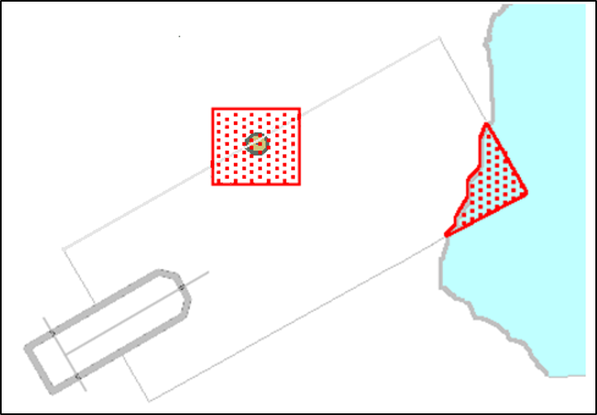
Figure 3 - Examples of danger highlights in ECDIS

Indications related to IENC accuracy

It should be possible for the boatmaster to select that the indications of 11.3.6 and 11.3.7
take into account accuracy information of relevant hydrographic information, as defined by IEHG
standards.

The selector used to take into account accuracy information must be called “Uncertainty”. The OEM may optionally split the uncertainty selector into separate horizontal and vertical components.

It should be possible for the boatmaster to select that the indications of 11.4.3, 11.4.4, 11.4.6, 11.4.7 and 11.4.8 take into account accuracy information of relevant hydrographic information, as defined by IEHG standards.

When the boatmaster has chosen to take accuracy of hydrographic information into account the Inland ECDIS or Inland ECS must use a zoneOfConfidence attribute to extend the check area in a horizontal direction for route plans (closer than a user-specified distance) and for own ship (within a specified time or distance set by the boatmaster, own ship will pass closer than a user-selected distance).

Check area extension value – S-401 only

When the Inland ECDIS or Inland ECS is using S-401 without any S-102 depth substitution or S-104 depth adjustment the S-401 QualityOfBathymetricData feature contains a zoneOfConfidence complex attribute. This provides either a horizontalPositionUncertainty sub-attribute. If no horizontalPositionUncertainty value is available then the amount of extension must be taken from the sub-attribute categoryOfZoneOfConfidence according to the following table of default values:

categoryOfZoneOfConfidence value. | Positional Accuracy
A1 | 5m
A2 | 20m
B | 50m
C | 500m
D | 500m
U | 500m
Table 3: categoryOfZoneOfConfidence and Accuracy values.

Check area extension value – S-102 depth substitution
When the depth information in the S-401 is substituted by S-102 the zoneOfConfidence.horizontalPositionUncertainty.uncertaintyFixed in the QualityOfBathymetryCoverage feature attribute table (S-100 Part 10c, 9.6.2) from the S-102 must be used instead of the S-401 feature information as defined in the last clause if it is set. If this value is not available then the S-401 value defined in the previous clause must be used instead.

Multiple QualityOfBathymetricData Features
For the S-401 case, when multiple QualityOfBathymetricData features with different categoryOfZoneOfConfidence values underlay the check area, then the value of extension changes at the point where the original non-extended check area crosses the boundary of the QualityOfBathymetricData areas with different categoryOfZoneOfConfidence values, see the example below:

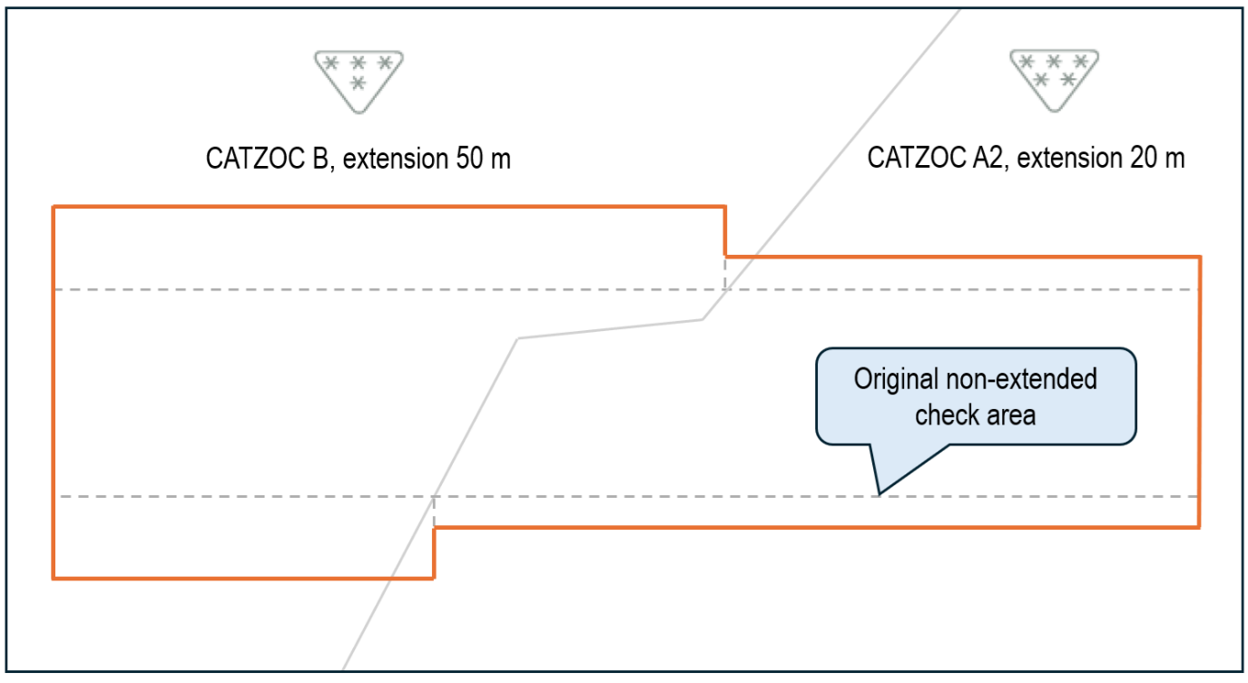

Fig 10. Example Extension of check-area by multiple underlaying QualityOfBathymetricData areas with different values of categoryOfZoneOfConfidence

Enhanced Safety Contour and Water Level Adjustment.
The term “Enhanced Safety Contour” means a safety contour created from bathymetric grid data using the value set by the user. With IENCs the user sets a value for the safety contour, but if a contour of that value is not found in the IENC then the safety contour defaults to the next deepest available contour which can be substantially deeper than the value requested by the user.
Bathymetric grid data allows the user the ability to define a value and for the system to delineate areas of safe and unsafe water based on that value. The areas defined can then be used for the definition of safety contour and attendant alerts/indications. When this is done contextual IENC features with depth information are also substituted from the bathymetric grid to present the user with a harmonised picture.
The combination of S-401 with S-102 and S-104 together enable Water Level Adjustment (WLA), allowing the water level data contained in S-104 to complement the S-102 and S-401 chart data. As with depth information, WLA processes adjust attribute values in the IENC data to present the user with a harmonised picture.
Appendix D defines the detailed mechanisms for Enhanced Safety Contour and Water Level Adjustment. The Inland ECDIS or Inland ECS must support the Enhanced Safety Contour and Water Level Adjustment features.

Coverages and Time Series for Gridded Data (S-102 and S-104)
Coverage and time series features are encoded in the HDF5 format (see S-100 Part 10c). S-100 provides for the following types of coverage and time series data:
- Gridded data with different types of spatial grid coverages;
- Data at a set of discrete fixed points;
- Data at a set of moving platforms;
- Time series data at a set of fixed points.
For S-102 and S-104 datasets, Inland ECDIS must support gridded data in DCF 2 format only (noting the one exception that S-102 QualityOfBathymetryCoverage group uses DCF 9).
Gridded data will specify either continuous or discrete interpolation (no interpolation between points) between grid points. Data for discrete fixed points, moving platform and time series at fixed points is intrinsically discrete.

Thinning
When gridded data is portrayed using discrete symbols at each data point, the effects of scaling the display must be considered. A high-resolution display (that is, zooming in) of regularly gridded data display produces a lower density of data in the visual field.
Displaying at a low resolution (that is, zooming out) increases the density of symbols in the visual field. However, by applying a thinning algorithm, the number of symbols may be reduced.
Thinning must therefore be applied to reduce symbol density when the display is scaled.
Manufacturers may use the recommended algorithm contained in Appendix G or other algorithms of their own devising.

Temporal variation
The metadata variables related to time are dateTimeOfFirstRecord, dateTimeOfLastRecord, timeRecordInterval, numberOfTimes, timeIntervalIndex, timePoint, startDateTime, and endDateTime (see S-100 Part 10c). The time selected for display (that is, past/present/future) will typically not correspond exactly to the timestamp (metadata variable timePoint) of the input data. For a correct display, the Inland ECDIS must select the correct data.
For data with only a single timed record (where the timestamp of the earliest value equals that of the latest value) such as real-time data, the data values must be displayed only if the display time is later than the timestamp and the absolute time difference between the display time and the data timestamp is less than a discrimination interval (for example 5 minutes). For a single record, the variable timeRecordInterval can be used to set the discrimination interval.
For data with multiple times, if the selected display time is later than the first timestamp and earlier than the last timestamp, or the selected display time is in the interval [startDateTime, endDateTime], then the closest but immediately preceding values in the data must be displayed.
If the selected time is later than the last timestamp or after endDateTime, then data values at that time must be displayed only if the absolute time difference between the display time and the data timestamp is less than a discrimination interval (for example the value of the variable timeRecordInterval). If the selected display time is outside the interval [(startDateTime – discriminationInterval), (endDateTime+discriminationInterval)] then the data must not be displayed.
Some data change rapidly, so more-or-less continual revision or updating of such data is essential. For real-time observations, new values are periodically collected (for example, on the order of once every 5 minutes). For a forecast, the entire field may be created one or more times per day. Other data, such as tidal atlas or harmonic constant data are updated much less often, typically on an annual basis.

Dual-fuel systems
Dual-fuel systems are systems that use both older (pre-S-100) and newer (S-100) data products that contain the same type of information (for example, S-57 based and S-401 IENCs).
All stakeholders should anticipate a transition period during which new S-100 formats are increasingly published to co-exist with older formats. An S-100 Inland ECDIS must be able to handle both S-57 based and S-401 IENCs during the transition period.

Concurrent applicability of S-52 and S-57
Dual-fuel capable systems must continue to use the principles defined in S-57 and S-52 for the presentation of chart data that conforms to S-57 instead of S-401. The principles of S-401 and this specification must be concurrently applied where S-401 data is displayed. This includes the case where one part of the chart window has S-401 data as the chart layer and another has S-57 based data as the chart layer – S-57/S-52 applies to the portion where S-57 based data is the chart layer and S-401 and this specification apply where S-401 data is the chart layer.
Seamless portrayal of S-401 data is described in Appendix E.
Overlays of S-100-based non-IENC data over S-57 based chart data are left to manufacturer discretion. Any overlays over S-57 based chart data must not interact with or modify the underlying chart data, in particular the Enhanced Safety Contour and Water Level Adjustment features must only be implemented over S-401 charts.
This specification is designed to allow such integrated displays. Note in particular:
- Any additional functions that apply only to S-100-data must be deactivated for S-57 based data.
- The principles for chart furniture and miscellaneous display elements (scale boundaries, limits of data, safety contour, depth zones, update identification, legend, etc) are the same in S-52 and this specification.
- The names of colour tokens are the same. (Future versions of this specification may add additional colour tokens, but should retain the S-52 set.)
- Management of viewing groups must be combined between S-57 and S-401. Viewing groups common to S-57 and S-100 should be managed as a single group.
Note that some elements required for complete compatibility of S-57/S-52 and S-401 presentations cannot be controlled in this specification, depending as they do on the harmonisation of Portrayal Catalogues with S-52 symbology, colour tables, and lookup tables. Among these are the shapes and dimensions of symbols and the colour coordinates assigned to colour tokens.

Appendix D – Enhanced Safety Contour and Water Level Adjustment

Enhanced Safety Contour
This Appendix defines how the “Enhanced Safety Contour” (ESC) feature is defined and implemented.
Enhanced Safety Contour, or ESC, means creation of the safety contour from the bathymetric grid data based on the value set by the user.
NOTE: On an S-100 Inland ECDIS with the Enhanced Safety Contour feature switched off (or an S-57 based Inland ECDIS), the user sets the value for the safety contour, but if the exact value is not found from the available depth information then the safety contour defaults to the next deepest which may be over 10 metres deeper than the value set by the user. The Enhanced Safety Contour feature addresses this issue.
The contents of this Appendix are not currently integrated with the existing S-100 portrayal mechanisms specified in S-100 Edition 5.2 Part 9. This may be rectified in future editions of S-100. Until then, this appendix contains the normative specification for these features and may use different language, terms and conventions than S-100 itself.
In these processes an end user selects:
- Suppression of specific S-401 features by S-102.
- A Safety Contour value of their choice.
When a user selects a safety contour value, outside areas of S-102 coverage the source for the displayed safety contour is the existing S-401 ENC (or S-57 ENC in dual-fuel mode) as defined in 11.6.1.
When the safety contour has been generated from S-102 data then the area over which it is generated, that is the S-102 coverage area, must be surrounded by a boundary line using colour token DEPWL see Figure D-1-1.
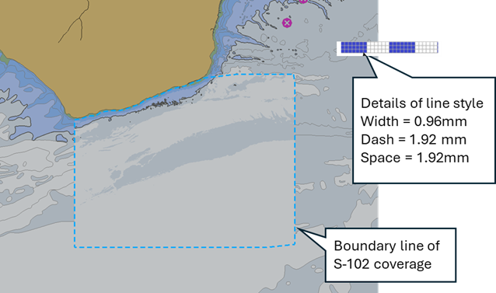
Figure D-1-1 - Boundary line of S-102 coverage

Provision of Sun Illumination
Sun illumination may be provided. Where provided:
- The boatmaster must be able to select whether it is enabled or not;
- Selection of Base or Standard Display must disable sun-illumination;
- The Inland ECDIS must use a consistent sun azimuth and elevation values for all data portrayed;
- The boatmaster should be able to vary the sun azimuth and elevation values.

Control over the use of S-102
The Inland ECDIS must only allow the use of S-102 for the application of ESC if at least one of the following conditions is met between the S-102 data and the extent of the IENC data it spatially coincides with:
- The data producer of the S-102 data is the same as the data producer of the IENC data; or
- The S-102 dataset has a digital signature issued by the IENC producer; or
- The Inland ECDIS has a certificate issued by the IENC producer with the S-102 data producer as its Subject.
Where certificates and identities are defined by clause 8.1.1

Data Constraints
- Portrayal of S-102 data and application of ESC must be restricted by minimum and maximum display scale values contained in the exchange catalogue as specified in clause 11.2.
- Coverage – S-102 data is not expected to overlap, but in case of an overlap of greater than one grid cell the Inland ECDIS must indicate an overlap by the text “OVERLAP” and the user must have the ability to select which producer in the overlapped area has priority and will be selected for processing safety contour. An alternative mechanism for selecting which producer in the overlapped area has priority may also be implemented by the Inland ECDIS.
  - Only datasets with overlapping scale ranges (as defined in clause 11.2) can contain overlapping data. Overlaps are then defined between spatially overlapping grid cells containing data, as opposed to grid cells with no-data (fill) values.
  - Datasets may contain overlapping grid cells, and different datasets may overlap, most commonly at national borders, but also in areas where there are multiple vertical datums within a single dataset. In these cases:
    - Overlaps within the same dataset (in areas with multiple vertical datums) the overlap must be resolved by taking the shoalest value for each grid cell (including vertical uncertainty when the Uncertainty selector is enabled) within the intersection. This is also used to resolve situations when the Boatmaster Selected Viewing Scale (BSVS) means that multiple grid cells are to be portrayed at the same screen position (the common point rule) – most often when the grid is being portrayed at a smaller zoom scale than the dataset resolution;
    - Overlaps between different producers. The end user must be able to select which dataset (or data producer) they wish to use.
- No complex interpolation is required between points in the S-102 grid. Nearest neighbour is used to define the depth in each S-102 point's neighbourhood (that is, the same depth everywhere within the grid square), regardless of any interpolationType defined for the S-102 dataset (S-100 Part 8, clause 8-7.7.3), as illustrated by Figures D-1-2 and D-1-3:
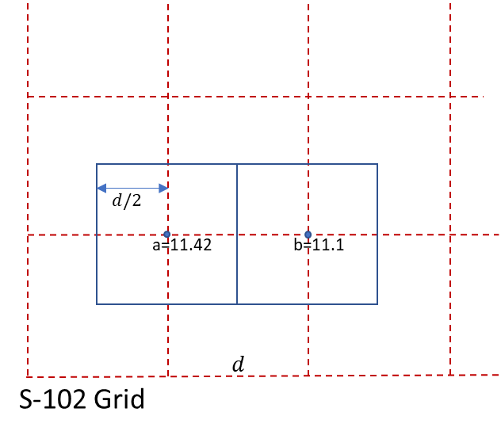
Figure D-1-2 - The extents of the S-102 points overlaid on the S-102 grid (grid spacing = ‘d’)
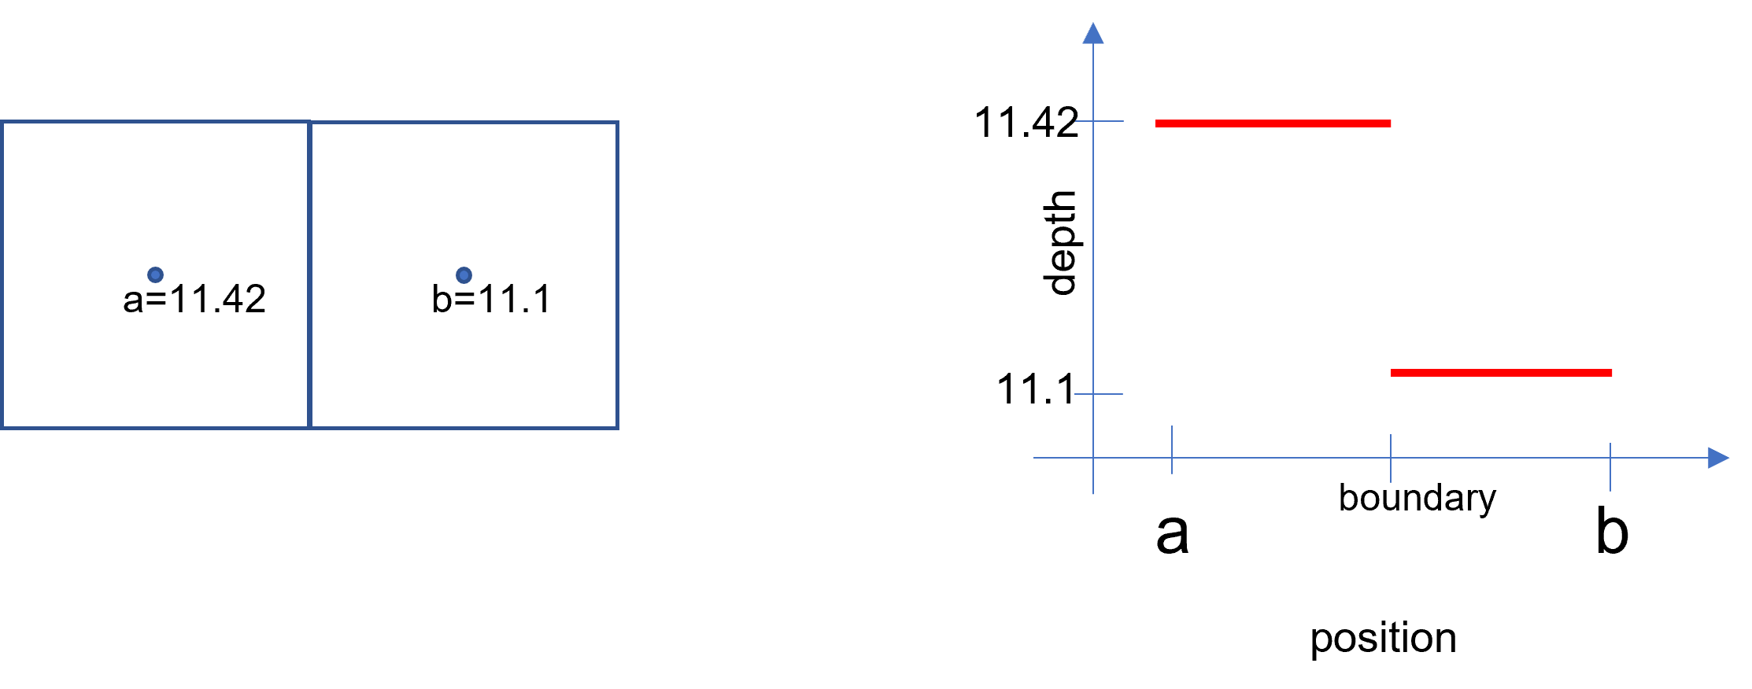
Figure D-1-3 - Extents of each S-102 points
showing nearest neighbour interpolation (S-100 Part 8-7.1.4)
- Only rectangular grids for S-102 are allowed. The method outlined may be extended to other grids; for example, triangular grids in the future.
- Enhanced Safety Contour must only be provided in areas where the Sounding Datum of suppressed S-401 features is the same as the vertical datum of the S-102 Coverage.
- When the Uncertainty selector is enabled vertical uncertainty information must be taken into account when extracting depth data from S-102 datasets.

Enhanced Safety Contour Selection and Implementation
The user must be able to select S-102 to be used as the source of the depth information and the Enhanced Safety Contour.
The Enhanced Safety Contour must be enabled by default.
When S-102 is selected for use, in areas where S-102 coverage exists, the S-102 suppresses the drawing instructions associated with the following S-401 depth features
- Depth Area
- Dredged Area
- Depth Contour
This also suppresses the safety contour, the shallow water pattern, Accuracy portrayal, text indicating the dredged depth and contour labels.
The process to construct the enhanced safety contour then consists of a selection of common edges from rectangular extents for each S-102 dataset point (including vertical uncertainty if the Uncertainty selector is selected), as shown in Figure D-1-4, where 11.2 metres is the threshold value set by the user.
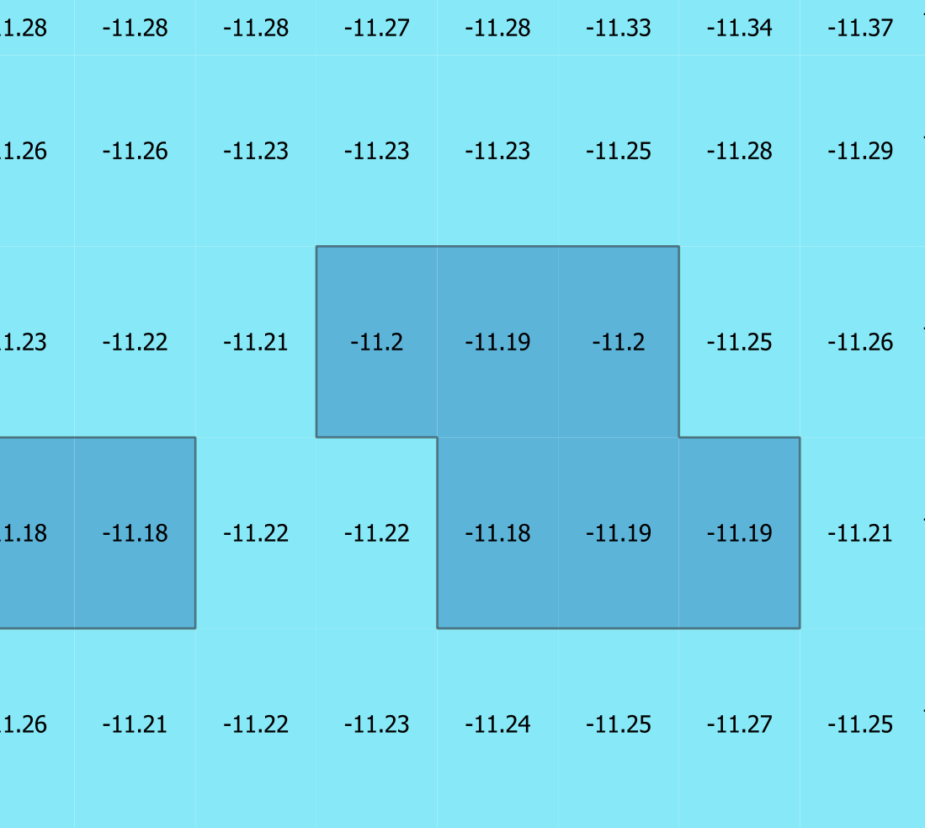
Figure D-1-4 - Common edges from rectangular extents
Common edges are selected when the S-102 points on either side of them lie on either side of the boundary of the safety contour value. In Figure D-1-5 below, 11.5 metres is the threshold value set by the user. Edges on the boundary of the dataset, or which lie between data values and S-102 fill values are not selected. See figure D-1-5
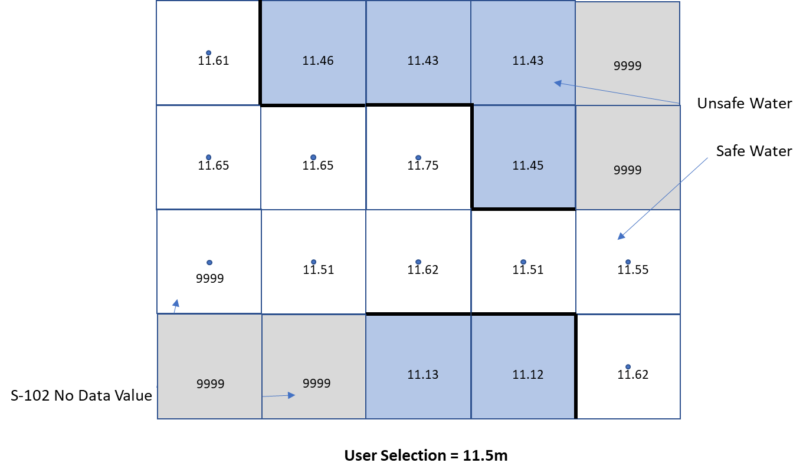
Figure D-1-5 - Edges from rectangular extents and at boundaries
The source of the displayed safety contour are the selected edges as defined.
The border defined in clause D-1 must be selected from data values only, which border the dataset, or around data fill values (S-102 No Data Value) which are not on the dataset border, for example:
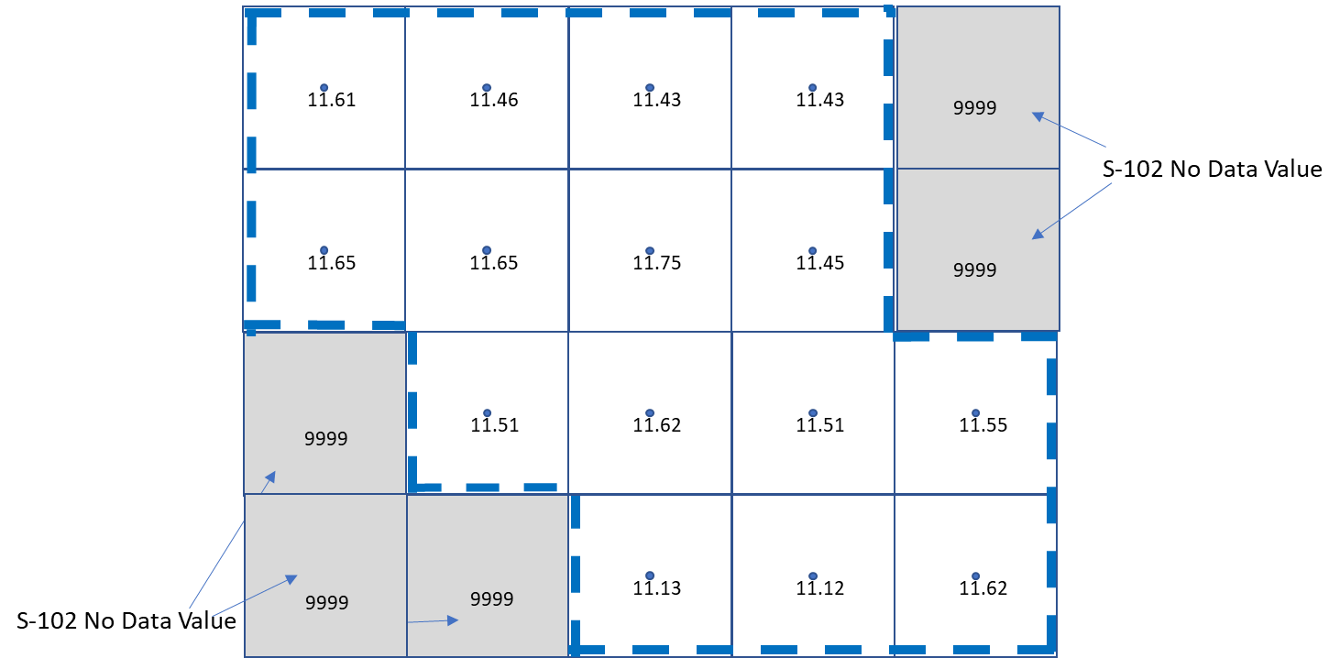
Figure D-1-6 – Construction of S-102 border
The combined effect of these drawing operations is shown in the following diagram:
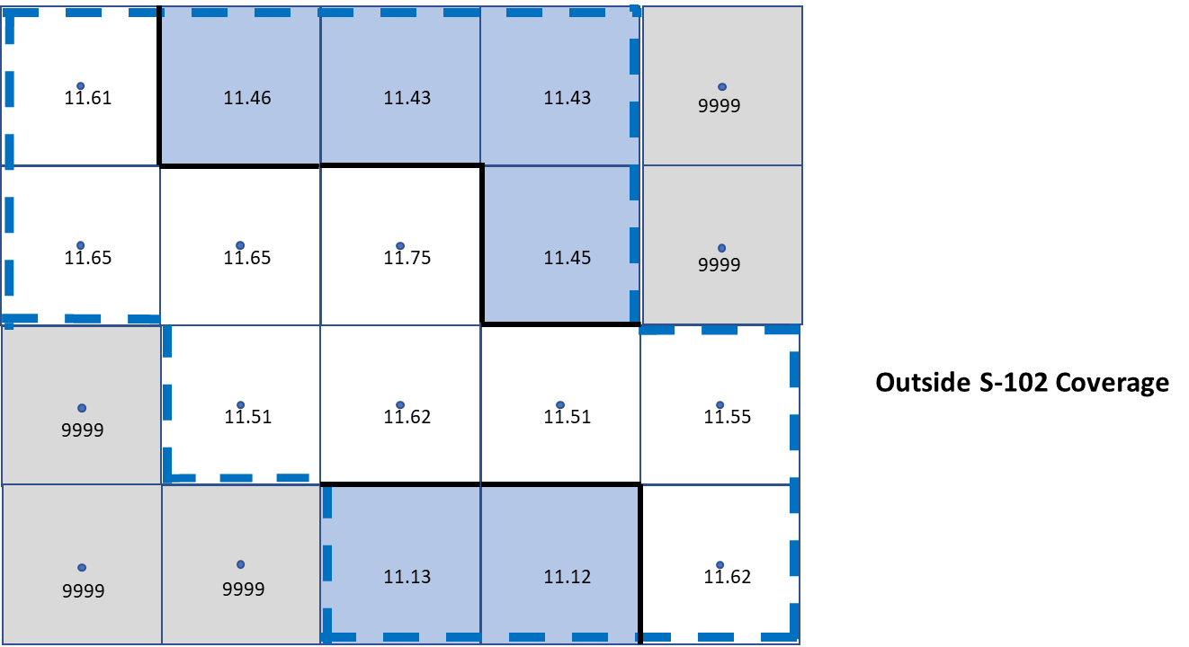
Figure D-1-7 – ESC construction

Vertical Uncertainty in the calculation of depth values.
When the Uncertainty selector is enabled calculation of depth values in S-102 datasets must take into consideration the vertical uncertainty contained within the dataset for all depth values. Vertical uncertainty is expressed as a positive number which indicates the maximum vertical uncertainty (and hence can be added or subtracted from a depth value contained in the S-102 dataset).
If the vertical uncertainty is stored in the grid cells themselves then each S-102 depth has its own uncertainty value which must be taken into account when extracting the depth values from the dataset.
If no uncertainty values are stored within the grid data then the value of maximumUncertainty must be used, these will be equal in a dataset with no separate uncertainty grid values.
If the maximumUncertainty value is equal to the dataset fill value, the depth value calculation must be handled as if the Uncertainty selector is not enabled.
Vertical uncertainty must only be taken into account when the Uncertainty selector is enabled.
Uncertainty values must be used in such a way as to safety-bias the depth calculation. Depth is encoded “positive-down” and therefore the uncertainty value must be subtracted from each of the individual depth values in order to achieve the required safety-bias.
With the user option “uncertainty” switched on:
Depth = (S-102 depth corrected for uncertainty) + (S-104 depth corrected for uncertainty)
= (S-102 depth value – S-102 uncertainty value) + (S-104 depth value – S-104 uncertainty value)
For example, given the following S-102 and S-104 depth and uncertainty values:
S-102 depth | 10.00 m
S-102 uncertainty | ±0.42 m
S-104 water level height | 0.32 m
S-104 uncertainty | ±0.04 m
Table 10: Example Values - Water Level Adjustment
The calculation is :
Depth = (10 – 0.42m) + (0.32m – 0.04m)
= 9.86m
With the user option “uncertainty” switched off, the calculation is simply:
Depth = (S-102 depth) + (S-104 depth)
Depth = 10m + 0.32m = 10.32m

Water Level Adjustment (WLA)
The user must be able to select depth information adjustment by water level height in areas where both S-102 and S-104 data products are available. This adjustment must then be applied in areas where compatible S-401, S-102 and S-104 data products are available
- The system must default to no water level adjustment.
- The boatmaster must be able to select one of the following methods of depth adjustment:
- Current (or user selected) date and time;
- A boatmaster specified date and time period;
- Where the route includes a schedule, the date and time of transit in each area along a route
- When Water Level Adjustment is activated as defined in this section:
- The functionality and portrayal of the safety contour, depth zone shades, safety depth and indication of isolated dangers must use the adjusted depth;
- The Inland ECDIS pick report must indicate both adjusted and unadjusted depth;
- Details of the Water Level Adjustment must at least be available on demand, such as the data source, temporal extent, and applicable areas;
- It must be possible to de-activate Water Level Adjustment via simple operator action;
- There must be a permanent indication as described in D-2.5, D-2.6 and D-2.7.
- S-104 vertical uncertainty values must additionally be used in all depth calculations if the Uncertainty selector is enabled.
- The Inland ECDIS voyage recording must include:
- The state of Water Level Adjustment (method applied);
- The boatmaster specified date and time or date and time period when in use for WLA, or the scheduled date and time, the check area distance and the time resolution when in use for WLA.

Scope
This clause defines how the “Inland ECDIS Water Level Adjustment feature” is implemented. Water Level Adjustment is referred to in this section as WLA. This section defines how the adjustment of depth information by water level is provided for:
- Selected single date and time;
- Selected date and time period;
- Linked to an estimated route schedule with selected check distance and time resolution.

Constraints on input data
- Coverage – As for S-102 data, S-104 datasets are not expected to spatially overlap within the same scale range, but in case of an overlap of greater than one grid cell the approach must be same as for overlapping S-102 data. The Inland ECDIS must provide a permanent indication of “Overlap” and the user must have the ability to select which producer in the overlapped area has priority and will be selected for processing WLA.
- As for S-102 data, the Inland ECDIS must only allow WLA processing if at least one of the following conditions is met between the S-104 data and the extent of the IENC data it spatially coincides with:
- The data producer of the S-104 data is the same as the data producer of the IENC data; or
- The S-104 dataset has a digital signature issued by the IENC producer; or
- The Inland ECDIS has a certificate issued by the IENC producer with the S-104 data producer as its Subject.
Where certificates and identities are defined by clause 8.1.1
- As with S-102, each S-104 point is assigned a rectangular extent with nearest neighbour interpolation.
- As with S-102, each S-104 value used in calculations must additionally take into account the vertical uncertainty values contained within the dataset when the Uncertainty selector is enabled.
- WLA must not be applied unless the S-102 and S-104 features are on the same vertical and horizontal datum. If the S-102 and S-104 features are not on the same vertical and/or horizontal datum then an indication “Incompatible datums” must be given to the user.

User Inputs
When WLA is selected for use, in areas where WLA coverage exists, one of the three different options must be used:
- WLA Option 1: WLA at a single date and time (current or user selected).
- WLA Option 2: WLA for a date and time period (from start date and time to end date and time).
- WLA Option 3: WLA linked to an estimated route schedule. In this case the user also specifies:
  - A distance parameter, the limit of the check area as specified by IMO MSC.530(106)/Rev.1 11.3.7 when route planning and MSC.530(106)/Rev.1 11.4.4 when route monitoring.
  - A time resolution t_{u} used to construct the individual WLA sections. This time resolution reflects the uncertainty or tolerance of the time schedule of the route, for example 10 minutes if the user assumes that they could follow the time schedule within 10 minutes.

Implementation - general
WLA can be applied only in areas where there is data from both S-102 and S-104. For example, the intersection of the Red and Blue outline in figure D-2-6 below. WLA is applied to S-401 features after substitution of depths by S-102 as defined in clauses D-1.2 and clause D-1-3.
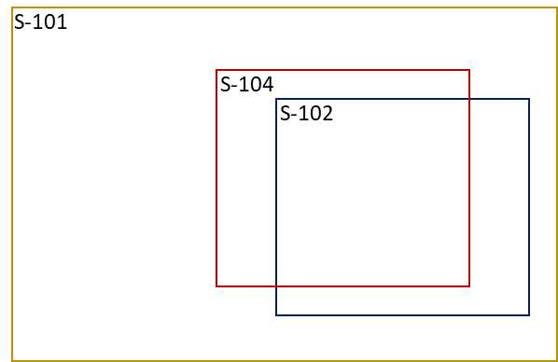
Figure D-2-6 - WLA can only be computed in areas where there is S-104 and S-102 data

Further, WLA can only be carried out:
- When WLA option 1 or WLA option 2 is selected, where the temporal extent of the S-104 fully covers the required date and time instant or period selected by the user
- When WLA option 3 is selected, where the temporal extent of the S-104 fully covers the estimated date and time of a part of the route; see figure D-2-16.
Where these conditions are not met the WLA processing must not be carried out.
When WLA has been processed the area for which it is defined must be surrounded by a boundary line using colour token DEPWL; see Figure D-2-7.

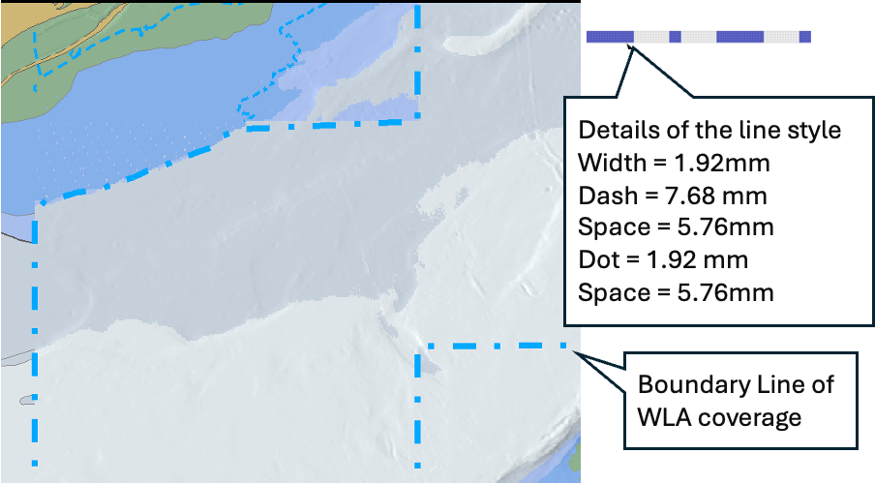
Figure D-2-7 - Boundary line of WLA coverage
NOTE: In this example S-102 coverage is larger than WLA coverage.
In addition to the display of the boundary line of the WLA coverage there should be a permanent indication about the application of WLA and the applied date and time, see details in WLA Options 1, 2 and 3.
In cases that the WLA area lines and ESC lines are co-located, only the WLA Area lines must be displayed
OEMs are free to design their user interface. Usable ideas include, for example, a mouse roller to change datetime, use of a slider to change datetime, or even to provide an animation from user selected start date and time to user selected end date and time.

Implementation of WLA Option 1 – WLA for a single datetime instant
WLA is based on S-104 values closest to the selected datetime instant. Each S-102 point has an extent of coverage which is closest to it. Each S-104 point, similarly has an extent. The adjustment of the S-102 values is calculated by adjusting each S-102 point by the shoalest of the S-104 values, for all S-104 points whose extent intersects the extent of the S-102 point.
When an S-104 record does not exist for the precise time specified the shoalest of the two S-104 adjacent values is selected from the S-104 dataset. S-104 values can only be selected within the temporal extent of the S-104 dataset. In the example shown in Figure D-2-8 (where S-104 values, “V” defined every 30 minutes and a user selected datetime of 07:24) the two values selected are 07:00 and 07:30, WLA would select 1.3m (the 07:00 value).
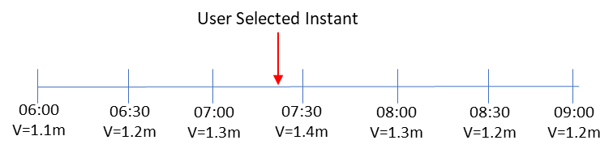
Figure D-2-8 - Selection of time-varying value
In Figure D-2-9 below, the S-102 point X is adjusted by the shoalest (that is, minimum) value of the S-104 values from (a), (b), (c) and (d) at the required datetime instant because the S-102 point extent overlaps the S-104 extents of a,b,c and d.
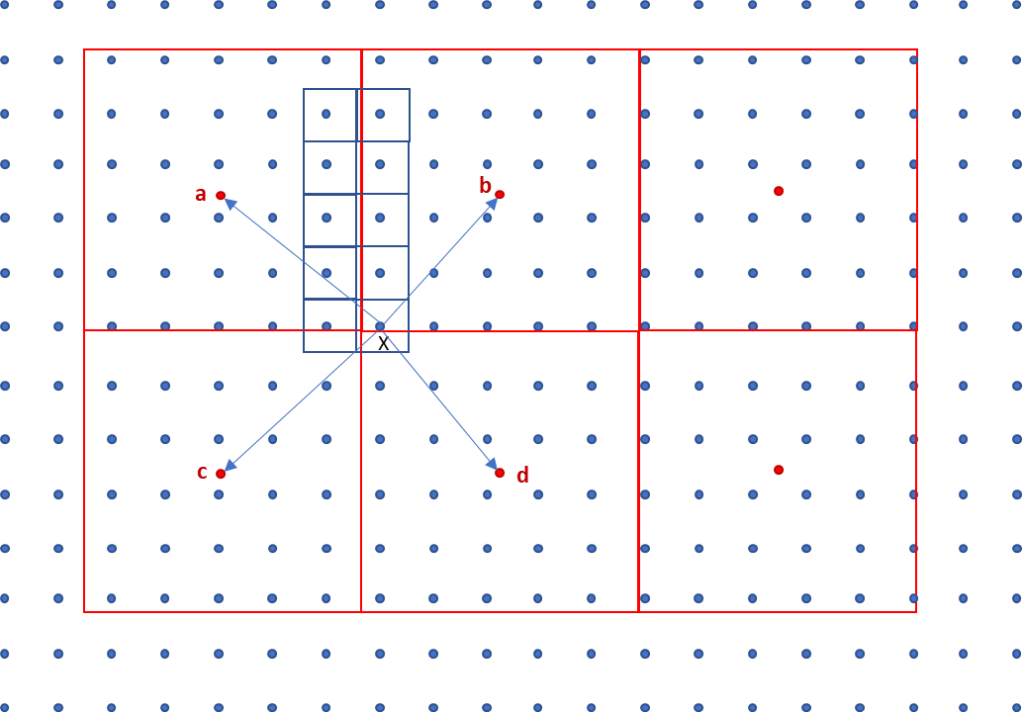
Figure D-2-9 - Adjustment of S-102 values by S-104
Format of the permanent indication is as below:
WLA 12:34 08 Nov 2021

Implementation of WLA Option 2 – WLA for a datetime range specified by the user as a time period
When WLA is based on a datetime range, then the process is identical to that followed for WLA Option 1 except each S-104 value selected is the shoalest of all values available in the S-104 within the selected time period.
All S-104 points contributing to the WLA must be defined across the time range required, otherwise the WLA is not computable and the user must be informed. The S-104 records selected are those which lie either within the user defined time period; immediately before the start point of the time period and immediatelyjust after the end point of the time period.
In the following examples:
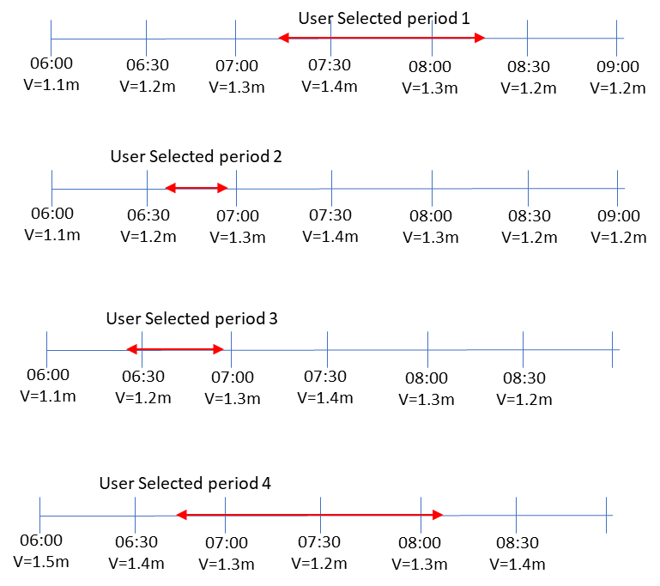
Figure D-2-10 - Examples of S-104 data selection
- User selected period 1, four values are from 0700, 0730, 0800 and 0830 - WLA would select 08:30 value = 1.2m (even though the time period doesn't overlap).
- User selected period 2, two values are from 0630 and 0700 - WLA would select 06:30 value V=1.2m (even though the time period doesn't overlap).
- User selected period 3, three values are from 0600, 0630 and 0700 - WLA would select 06:00 V=1.1m (even though the time period doesn't overlap).
- User selected period 4, five values are from 0630, 0700, 0730, 0800 and 0830 – WLA would select 07:30 V=1.2m.
When adjusting depth values the shoalest (smallest) value from the selected S-104 records must be used in order to produce the safest WLA values.
Format of the permanent indication is as below:
WLA from 12:34 08 Nov 2021 to 14:56 08 Nov 2021

Implementation of WLA Option 3 – linking of WLA to a defined route with planned waypoints and times
When WLA is based on a route then the limit of check area around the route is set by the user as specified by IMO MSC.530(106)/Rev.1 11.3.7.
The same user-specified distance must be used for the check of safety contour, prohibited areas, geographic areas for which special conditions exist and navigational hazards and equivalent requirements when route monitoring.
The WLA is processed within this check area. The boundary of the area of the display where WLA has been carried out must be displayed (as shown in figure D-2.16). In the process description this distance is referred to as ‘a’.
A route could be either a Planned route or a Monitored route. Both could be processed for the WLA, but not at the same time in a single display area. In case of multiple display areas, it is possible that one area is WLA processed for Planned route and another area is WLA processed for the Monitored route.
For a Planned route the datetime period applied for the WLA process is based on the schedule of the planned route itself.
For a Monitored route the datetime period applied for the WLA process is user selectable either:
- Based on the planned schedule of the monitored route itself; or
- Based on the monitored route adjusted for the current own ship position.

When WLA is based on the planned schedule and own ship is not keeping to schedule a Caution must be raised to indicate the water level being experienced may be different to that being applied by the ECDIS.
The region of WLA is restricted to a distinguishable bordered polygon around the route. The process works as follows:
- For each section of the route a series of estimated time markers is defined along the route at times t₀ – t_{n}. The diagram also shows the “limit of check area” as specified by IMO MSC.530(106)/Rev.1 11.3.7. Each time marker is delimited before and after by the time +/- half the user selected t_{u} interval so the rectangle in the diagram represents the extent of time t₁ which ranges from time $t_{1}-\frac{t_{u}}{2}$to $t_{1}+\frac{t_{u}}{2}$. This is the WLA adjustment polygon (shown in red) corresponding to time t₁:
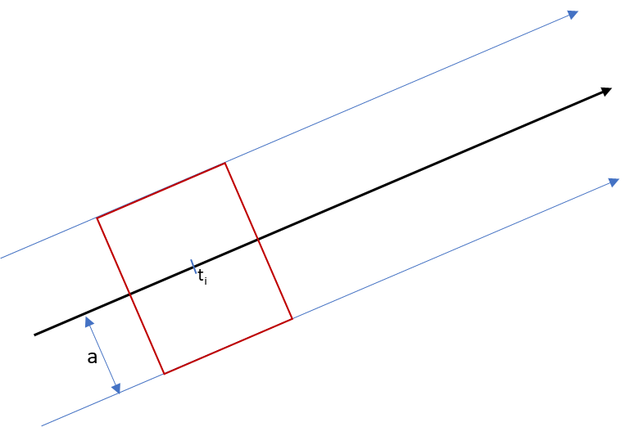
Figure D-2-11 - WLA adjustment polygon
- Where the route follows a curved section the polygon formed is not a rectangle but an area defined by the user selected limit as shown by areas a and b:

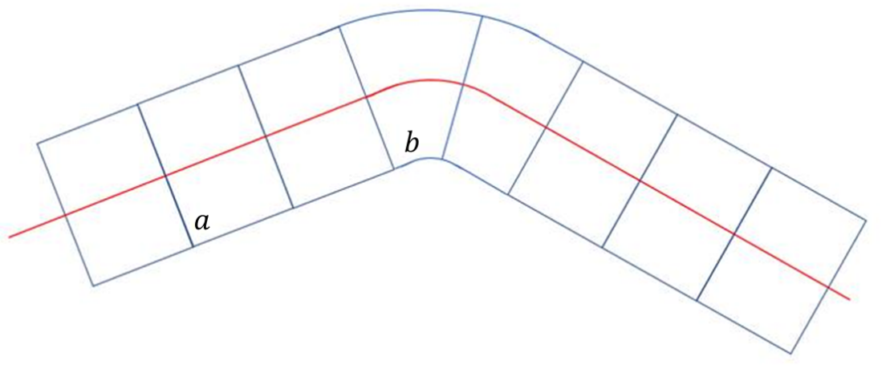
Figure D-2-12 - WLA adjustment polygon along curved section
- The individual S-102 points (blue dots in Figure D-2-13 below) are assigned rectangular extents. For each WLA adjustment rectangle corresponding to each t_{i} the S-102 extents which spatially intersect are selected. A full example is shown in Figure D-2-13 for one of the WLA polygons (shown in red).
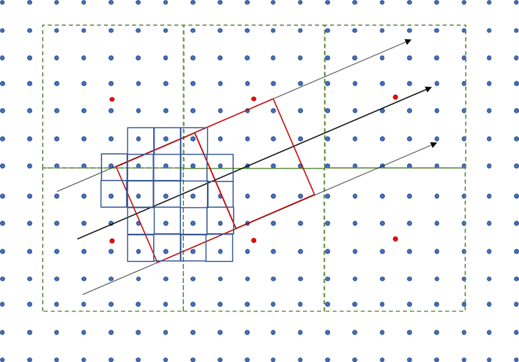
Figure D-2-13 - Grid cell selection
- For each S-102 point whose extent intersects the WLA adjustment polygon the Water level is adjusted using a similar process to Option 1. The S-104 value used for adjustment is the shoalest value from each of the S-104 points whose extents intersect the S-102 point (as described in WLA Option 1) across the time period ($t_{i}-\frac{t_{u}}{2}$) and ($t_{i}+\frac{t_{u}}{2}$). In Figure D-2-14, illustrating this step, two S-102 points are adjusted by S-104 values in the time period ($t_{1}-\frac{t_{u}}{2}$) and ($t_{1}+\frac{t_{u}}{2}$), for calculation of t₁. S-102 point $x$ is adjusted using values drawn from S-104 points a and b (because its extent intersects the extents of points a and b) and S-102 point y is only adjusted with values from S-104 point b.

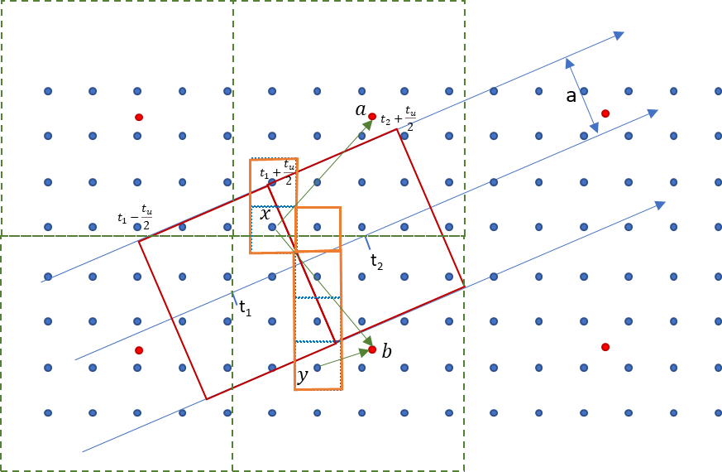
Figure D-2-14 - Selection of S-104 data
- Each of the S-102 points are assigned the adjusted water level equal to the S-102 value + the calculated (shoalest) S-104 value as defined in the previous step.
- Once the WLA polygon for time t_{i} is processed the WLA polygon for time t_{i+1} is processed.
- S-102 points whose extents are intersected by the both the WLA polygon for t_{i} and t_{i+1} are assigned the shoaler of the two values, that is the shoalest of the S-104 values between the two time periods ($t_{i}-\frac{t_{u}}{2}$) and ($t_{i}+\frac{t_{u}}{2}$), and ($t_{i+1}-\frac{t_{u}}{2}$) and ($t_{i+1}+\frac{t_{u}}{2}$).
This completes the WLA process for (red) polygon t_{i} . In Figure D-2-15 below the orange border shows S-102 points lying in WLA polygons t₁ and t₂ and which would be assigned the shoaler of the two S-104 values corresponding to the t₁ and t₂ WLA process.
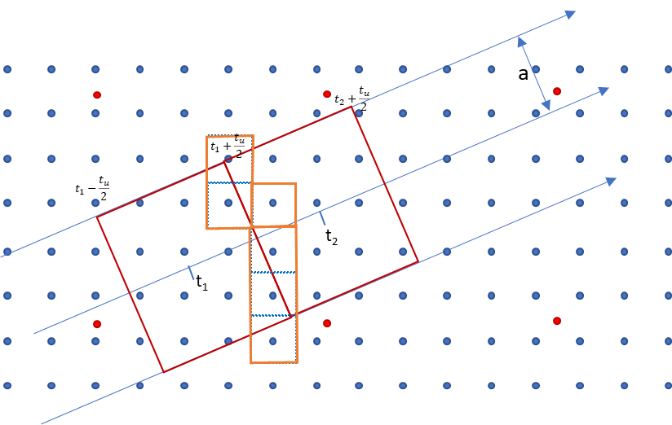
Figure D-2-15: Time-dependent adjustment of S-102 data with S-104 data
This process is extended to all t_{i} along the planned route.
Figure D-2-16 shows a boundary line around all the WLA processed S-102 grid cells. This marks the boundary of the Water Level Adjustment area and requires portrayal to inform the user which areas of the display are subject to WLA. This area is surrounded by a distinguishable boundary line using colour token DEPWL).
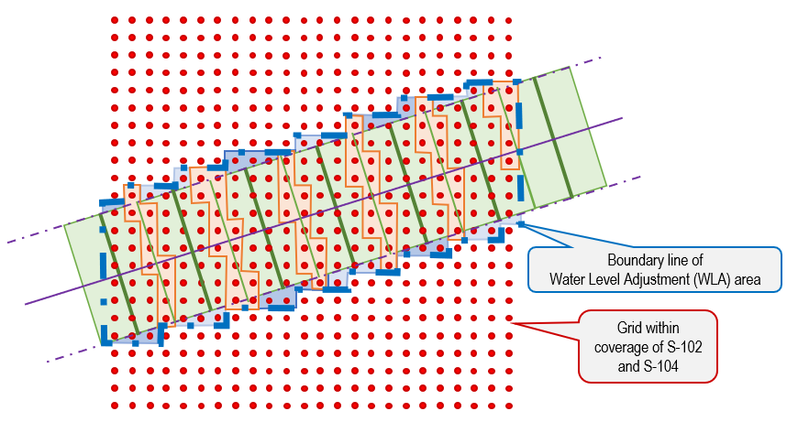
Figure D-2-16 - Boundary of adjusted area
Figure D-2-17 below shows how the rectangle is positioned in the middle of S-104 coverage area and at the edge of the S-104 coverage are.
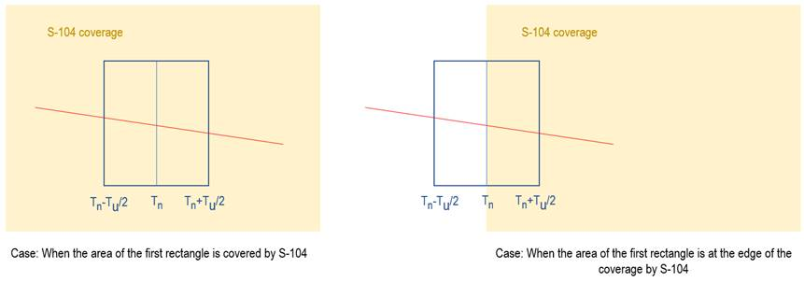
Figure D-2-17 - Positioning in interior and at edge
Format of the permanent indication is as below:
WLA from 12:34 08 Nov 2021 to 14:56 08 Nov 2021

Treatment of depth and water level related S-401 features

Substitution and adjustment of depth values
In areas covered by only S-102, all depth values must be substituted for all IENC features which have depth attribution (that is, the attribute valueOfSounding bound to them in the S-401 Feature Catalogue and the z value of soundings), when viewed at a MSVS that is larger than or equal to the minimumDisplayScale of the overlapping S-102 dataset
In areas where WLA is processed, all depth values must also be adjusted for all ENC features which have depth attribution (that is, the attribute valueOfSounding bound to them in the S-401 Feature Catalogue).

Areas covered by S-102 only or by both S-102 and S-104
Adjustment of different geographic primitives.
- Point Features
  - For Areas covered by S-102 only, a value for the attribute valueOfSounding must be taken from the S-102 grid cell extents which intersect the point feature (as shown in Figure D-3-18).
  - For Areas covered by S-102 and S-104, the value for attribute valueOfSounding must be taken from the S-102 grid cell extents which intersect the point feature. WLA is then applied to this value using S-104 records selected from the S-104 grid cell intersecting the point feature. The S-104 value selected is as defined in clauses D-2.5, D-2.6 and D-2.7.
- For Curve and Surface features
  - For Areas covered by S-102 only, the value for valueOfSounding must be the shoalest value of all S-102 grid cells whose extents intersect the feature’s geometry within the S-102 coverage available. If the curve or surface feature is not completely within the S-102 then the value defined is the shoalest resulting from the original feature value in S-401 attribute and the value selected from the intersecting S-102 grid cells.
  - For Areas covered by S-102 and S-104, the value for valueOfSounding is first selected, as the shoalest value of all S-102 grid cells whose extents intersect the feature’s geometry. WLA adjustment must then applied to this value by selecting the shoalest value from all intersecting S-104 grid cells. The value selected is as defined in clauses D-2.5, D-2.6 and D-2.7 and shown in Figure D-3-19. If the curve or surface feature is not completely within the S-104 coverage then the adjusted value is the shoalest value resulting from the original feature value in S-401 attribute and the WLA adjusted value.
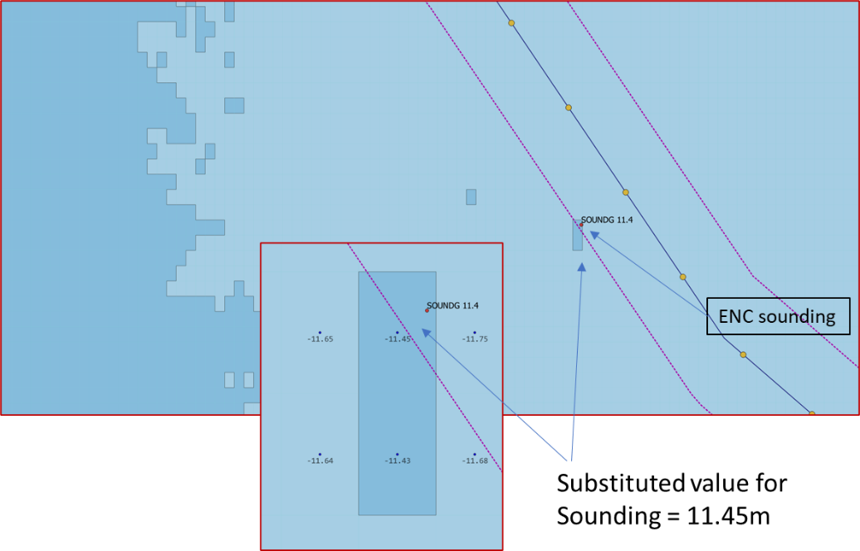
Figure D-3-18 - Substitution of sounding value from S-102
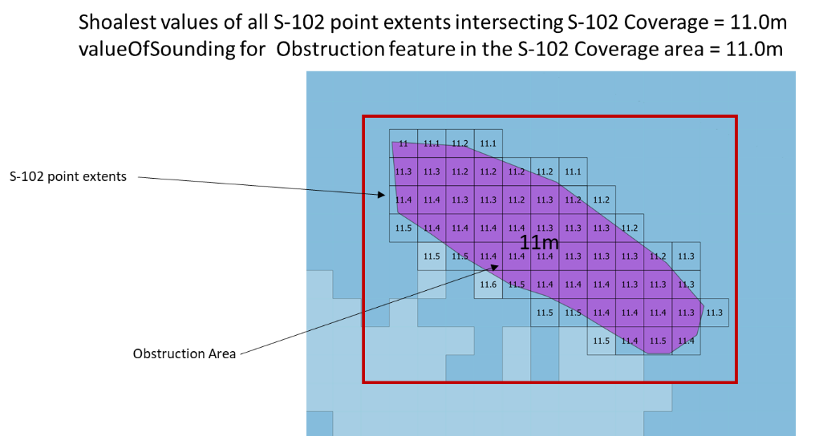
Figure D-3-19 - Substitution of valueOfSounding attribute in S-401 Obstruction from S-102 data
The S-401 features for which this depth substitution must be implemented within S-102 coverage areas are all those which bind valueOfSounding in the S-401 feature catalogue along with multipoint geometries, unless specifically excluded in this clause.
Soundings are included (either individual soundings or those which are part of an array) substituting the S-102 grid cell whose extents intersect the sounding position for the defined ZCOO (ISO8211), See figure D-3-18.
If the depth substituted S-401 feature is covered by S-104, then WLA must be processed using the same method as for the underlying depth area.
Depth values must also be substituted in all IENC features at all scales which have the attribute depthRangeMinimumValue bound to them in the S-401 Feature Catalogue.
For all features with substituted (and possibly adjusted values), the Inland ECDIS Pick Report must indicate the substituted/adjusted value and its source. The format and portrayal of depths and drying heights (that is, number of decimals, etc) is unchanged.
For example, for S-102 only covered area:
Value Of Sounding 12.3 m [S-102]
When an S-401 attribute has been WLA adjusted the pick report must indicate the WLA adjusted value, source and time/date. The format of time date is: hh:mm dd mmm yyyy.
For example, for both S-102 and S-104 covered area:
Value Of Sounding 15.5m [WLA 12:34 08 Nov 2021]
Value Of Sounding 15.5m [WLA from 12:34 08 Nov 2021 to 14:56 08 Nov 2021]

Adjustment of vertical clearance values in areas covered by both S-102 and S-104
Where S-401 features contain features with vertical clearance values, and the S-104 vertical datum matches the sounding datum defined for the S-401 feature, and a datum correction value is supplied in the S-401, then then the S-401 vertical clearance values must also be calculated and adjusted.
Adjustment of vertical clearance values must only take place in areas where S-102 and S-104 coverage overlaps and WLA is applied. Where the datum correction values are not included in S-401 or not available (as defined in this clause) the calculations must not be applied.
Any vertical clearance value adjustment must be adjusted using the intersecting S-104 grid cell(s) water level value and using the maximum of all intersecting S-104 data grid cells. Adjustment must only be applied on any features which intersect with the coverage of the S-104 data.
Adjustment is defined for all features which bind verticalClearanceValue in the S-401 feature catalogue using either verticalClearanceFixed, verticalClearanceSafe, verticalClearanceOpen or verticalClearanceClosed unless specifically excluded in this clause.
The S-401 attribute adjusted is verticalClearanceValue. When adjusting vertical clearance values the largest9 value from all intersecting S-104 records must be used in order to produce the safest values.
The vertical clearance defined on each S-401 feature must be corrected using the S-104 value and the datumSeparationValue. The datumSeparationValue (if available) is included in the complex attribute of the S-401 feature containing the verticalClearanceValue, which may be verticalClearanceFixed, verticalClearanceSafe verticalClearanceOpen or verticalClearanceClosed.
For example the datum difference information datumSeparationValue on a verticalClearanceFixed complex attribute is contained in:
verticalClearanceFixed.datumDifferenceInformation
with the vertical clearance value to be adjusted defined in :
verticalClearanceFixed.verticalClearanceValue
Note that datum difference information is not mandatory and may not always be defined for all S-401 features which define vertical clearance.
When adjusting the vertical clearance the following formula must be used:
Adjusted verticalClearanceValue = verticalClearanceValue_{S-401} + datumSeparationValue_{S-401} – S-104 value9
See also the footnote to Table 10: Example Values - Water Level Adjustment regarding positive and negative values for S-104 data.
Additionally, if the user has the Uncertainty selector selected (clause 11.9.10), then the S-104 value must also be adjusted according to the S-104 vertical uncertainty value and the following formula must be used:
Adjusted verticalClearanceValue = verticalClearanceValue(S-401) + datumSeparationValue(S-401)) – S-104 value9 - S-104 uncertainty
The user must be given a permanent indication that the Water Level (S-104) values have adjusted S-401 attribute values in the data display as described in D-1.5, D-1.6 and D-1.7. Where vertical clearance values are adjusted as defined in this clause the permanent indication given to the user must indicate that some or all vertical clearance values have been adjusted. Any alerts that take into account vertical clearance must also include the adjusted figure.
When verticalClearanceValue in S-401 has been substituted or adjusted the Inland ECDIS Pick Report must indicate the substituted value, source and time/date

Alerts and indication details
Substituted or adjusted values in IENCs at the largest scale must be used as input to any alert/indication processing. The substituted values are portrayed as shown in Figure D-3-20 which shows the graphical highlight (red boundary and red transparent fill) for the intersected safety contour.
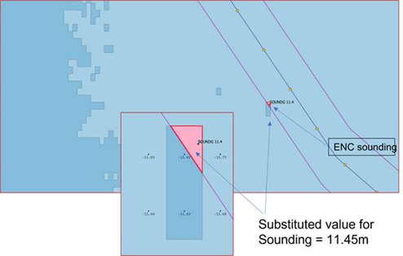
Figure D-3-20 - Graphical highlight for intersected safety contour

Legend details
As stated in 11.10.1, the legend must indicate the vertical datum of S-102 and S-104. If the vertical datums are the same then a single indication is enough to cover S-401, S-102 and S-104.

R = LsmaxnD < Rmax

n =1+ fixLsmaxDRmax

xk=x0±n×kyk=y0±n×k for k=0, 1, 2, 3 …

R= Lsmax1×D = 30.436 =0.844 >0.5

n=1+ fix30.436×0.5=2

xk = x0 ± 2×kyk = y0 ± 2×k for k=0, 1, 2, 3 …

n=1+ fix30.436×0.33=3

xk =x0 ±3×kyk=y0±3×k for k=0, 1, 2, 3…

- φλ

kO=0.9996

1f
1f=aa-b
×10-3
b=a 1-f
b=6356752.31425

- λ0

λ0=183-(6×Nz)° W
λ0={6×Nz-30-3}° E
Nz=45λ0=87° Eλ087° E

e= 2f-f2=8.18191908 × 10-2
n= f(2-f)=1.67922039 × 10-3
B=a(1+n)1+n24+n464=6367449.145823415
h1'=n2-23n2+3796n3+1360n4=8.37732164 ×10-4
h2'=148n2-115n3+4371440n4=5.84321837 × 10-8
h3'=17480n3-37840n4=1.67348888 ×10-10
h4'=4397161280n4=2.16773776 × 10-13

η'=E-FEB kO= (E-500000)6364902.166165086

ξ'=(N-FN)BkO=(N-FN)6364902.166165086

ξ1'=h1'sin2ξ'cosh2η'η1'=h1'cos2ξ'sinh2η'
ξ2'=h2'sin4ξ'cosh4η'η2'=h2'cos4ξ'sinh4η'
ξ3'=h3'sin6ξ'cosh6η'η3'=h3'cos6ξ'sinh6η'
ξ4'=h4'sin8ξ'cosh8η'η4'=h4'cos8ξ'sinh8η'
ξ0'= ξ'- ξ1'+ξ2'+ξ3'+ξ4'η0'= η'-η1'+η2'+η3'+η4'

β'=sin-1sinξ0'coshη0'
Q'=sinh-1tanβ'
Q"=Q'+e tanh-1e tanhQ'
=Q'+e tanh-1e tanhQ"Q"<10-8

φ=tan-1sinhQ"180π
λ=λO+sin-1tanhη0'cosβ'180π

- φλ

kO=0.994

1f
×10-3
e= 2f-f2=8.18191908 × 10-2

- t'
t'=E-FE2+(N-FN)2(1+e)(1+e)(1-e)(1-e)2akO
=7.91307065 ×10-8(E-2000000)2+N-20000002

- χ
χ= π2-2tan-1t'

- φ
φ= 180πχ+e22+5e424+e612+13e8360sin2χ+7e448+29e6240+811e811520sin4χ+7e6120+81e81120sin6χ+4279e8161280sin8χ
=180πχ+3.35655147×10-3sin2χ+6.57187270×10-6sin4χ+1.76456433×10-8sin6χ+5.32847842×10-11sin8χ

Eλ=0°
λ=180πatan2E-2000000,2000000-N

- φλ

kO=0.994

1f
×10-3
e= 2f-f2=8.18191908 × 10-2
- t'
t'=E-FE2+(N-FN)2(1+e)(1+e)(1-e)(1-e)2akO
=7.91307065 ×10-8(E-2000000)2+N-20000002

- χ
χ= 2tan-1t'-π2

- φ
φ= 180πχ+e22+5e424+e612+13e8360sin2χ+7e448+29e6240+811e811520sin4χ+7e6120+81e81120sin6χ+4279e8161280sin8χ
=180πχ+3.35655147×10-3sin2χ+6.57187270×10-6sin4χ+1.76456433×10-8sin6χ+5.32847842×10-11sin8χ

Eλ=0°
λ=180πatan2E-2000000,N-2000000

Portrayal, Interrogation via Pick Reports and Inclusion in Update Status Reports.
For colour token DEPWL, xyL values are: DAY x= 0.15, y=0.15, L=30.0; DUSK x=0.15, y=0.15, L=7.5; NIGHT x=0.15, y=0.15, L=1.2
In the case of a difference in resolution the maximum overlap is the size of the larger of the overlapping grid cell.
Although depths are always measured positive down in S-102 it is also possible for S-104 to be encoded either positive up or positive down. S-104 contains the attribute verticalCS which determines whether water level is encoded positive up (6498) or positive down (6499). In the example the water level height of 0.32 m would need to be multiplied by -1 if the S-104 verticalCS is 6499
In the case of a difference in resolution the maximum overlap is the size of the larger of the overlapping grid cell.
Thick dark blue dash line, colour token DEPWL xyL values are: DAY x= 0.15, y=¬0.15, L=30.0; DUSK x=0.15, y=0.15, L=7.5; NIGHT x=0.15, y=0.15, L=1.2.
thick dark blue dash dot line, colour token DEPWL, xyL values are: DAY x= 0.15, y=¬0.15, L=30.0; DUSK x=0.15, y=0.15, L=7.5; NIGHT x=0.15, y=0.15, L=1.2
See also the footnote to Table 10: Example Values - Water Level Adjustment regarding positive and negative values for S-104 data. This section is written with the assumption that S-104 values are positive depths, therefore the maximum of values should be used in order to produce the safest values. This should be modified if S-104 has negative (i.e. depth up) values to ensure the safest values are produced in all cases.

